Video Lecture Transcript Q&A Bot

Design Document
C-DAC, Bangalore
Version 1
<date of creation>

Prepared By:
<name>

Project Code 4
Date 4
Prepared by 4
Introduction 4
Purpose 5
Scope 5
Intended Audience 5
References 5
Acronyms, terms and definitions 5
Assumptions and constraints 6
Basic Design approach 6
Risks 6
System overview 6
Architecture Design 6
Data Design 10
API Gateway Repository 10
API Repository 12
Component Design 26
Work-flow Summary w.r.t Identifying Components : - 26
Identified Components List for the MoLE Ecosystem for Sandbox 28
Users Registration 28
API Gateway 29
APIs and Description 31
UAN Generation 31
UAN Search 35
UAN Details Updation 42
Family Detail Entry 46
Consent 52
AADHAAR Vault 52
Security Control 54
Reporting 54
Interface Design 56
Any Specific Design Considerations 57
Design Test 57
Cross Reference with System Requirement Specification 57

Introduction
Introduction to the project.

Purpose
The purpose of this project is to develop an AI-powered educational platform that allows students and instructors to interact with lecture video content using natural language questions. The system automatically converts lecture videos or audio into searchable transcripts using speech recognition technology and Retrieval-Augmented Generation (RAG).
The platform helps students quickly find explanations, concepts, timestamps, and answers from lengthy lecture recordings without manually watching the entire video again.
The system also supports multi-language audio transcription and question-answering, enabling lectures in different regional and international languages to be processed and queried efficiently.

Scope
The Video Lecture Transcript Q&A Bot is an internal AI-based educational platform developed for academic institutions, training centers, and e-learning environments.
The scope of the project includes:
- Uploading lecture videos/audio files
- Automatic speech-to-text transcription
- Multi-language audio processing
- Transcript chunking and semantic indexing
- AI-powered question-answering from lecture content
- Timestamp-based answer citations
- Lecture analytics and management dashboard
- Student and instructor interaction system
- Role-based secure access
- Real-time streaming AI responses
The system will be deployed in a Linux server environment and accessed through modern web browsers.
The platform can be used internally by institutions for smart lecture management, digital learning assistance, and AI-supported education systems

Intended Audience
The document is intended to be read and understood by all the design, development and testing teams and should be referred to at all stages.

References
- Functional Requirement Specifications (FRS)
- OpenAI Whisper Documentation (https://github.com/openai/whisper)
- ChromaDB Documentation (https://docs.trychroma.com)
- Groq API Documentation (https://console.groq.com/docs)
- FastAPI Documentation (https://fastapi.tiangolo.com)
- React Documentation (https://react.dev)
- Sentence-Transformers Documentation (https://www.sbert.net)

Acronyms, terms and definitions

RAG | Retrieval-Augmented Generation – a technique that combines information retrieval with LLM-based text generation
LLM | Large Language Model – an AI model trained on large text corpora for natural language understanding and generation
ASR | Application Programming Interface – a set of endpoints exposed by backend and RAG services
JWT | JSON Web Token – a compact token format used for secure authentication
CORS | Cross-Origin Resource Sharing – a security mechanism for controlling cross-domain requests
ORM | Object-Relational Mapping – SQLAlchemy maps Python objects to database tables
ChromaDB | An open-source vector database used for storing and retrieving text embeddings
Whisper | OpenAI’s automatic speech recognition model supporting 99+ languages
Groq | A cloud inference platform providing fast LLM API access (llama-3.3-70b-versatile)
FFmpeg | A multimedia framework used for extracting audio from video files
Embedding | A dense numerical vector representation of text used for semantic similarity search
Cosine Similarity | A metric measuring the angle between two vectors to determine semantic similarity

Assumptions and constraints
Assumptions:
- Users have a modern web browser (Chrome, Firefox, Edge, Safari) with JavaScript enabled
- The deployment environment has sufficient RAM (minimum 4 GB) for running Whisper speech recognition models
- FFmpeg is available in the RAG service environment for audio extraction from video files
- A valid Groq API key is available for LLM-based answer generation
- PostgreSQL 16 or higher is available as the relational database
- Internet connectivity is available for accessing the Groq cloud API during query processing
Constraints:
- The Whisper model size (tiny/base/small) is constrained by available server memory – base model requires approximately 1 GB RAM
- Video file upload size is limited by server configuration and available disk space
- Real-time transcription is not supported – videos must be fully uploaded before processing begins
- The system currently supports single-user concurrent processing per RAG service instance
- ChromaDB vector store is file-based and not horizontally scalable without architectural changes
- The Groq API has rate limits that may affect concurrent query throughput

Basic Design approach
The project Video Lecture Transcript Q&A Bot is a web-based Retrieval-Augmented Generation (RAG) platform that allows users to upload lecture videos, automatically transcribe them, index the content into a searchable vector database, and ask questions in natural language. The main goal is to reduce the time spent searching through long lecture recordings by turning them into an interactive knowledge system.

The system is designed as a modular, service-oriented architecture with three main components:

- Frontend Application
- Built using React, Vite, and TypeScript.
- Provides login, dashboards, video upload interface, and Q&A experience.
- Supports both user and admin roles.

- Backend API Service
- A RESTful API built with FastAPI handling authentication, user management,
chat sessions, video metadata, complaints, alerts, and analytics

- RAG Processing Service
- A specialized FastAPI service responsible for the complete RAG pipeline:
video ingestion (audio extraction, transcription, translation, chunking,
embedding, vector storage) and query processing (embedding, retrieval, LLM
answer generation)

The services communicate via HTTP REST APIs. The frontend calls the backend for authentication and CRUD operations, and directly calls the RAG service for video ingestion and question-answering. In production, an Nginx reverse proxy routes requests to the appropriate service.
The RAG pipeline follows a sequential processing model: Video → Audio (FFmpeg) → Transcript (Whisper) → Translation (Whisper, if non-English) → Chunks (sentence-aware splitting) → Embeddings (sentence-transformers/all-MiniLM-L6-v2) → Vector Store (ChromaDB). Query processing follows: Question → Embedding → Vector Search (top-4 chunks) → Context Assembly → LLM Generation (Groq llama-3.3-70b-versatile) → Answer with Sources.

Risks
 | Risk | Impact | Mitigation
1 | Groq API downtime or rate limiting | Users cannot get answers to questions | Implement caching of previously answered questions; display informative error messages
2 | Large video files exhausting server disk/memory | Service crashes during transcription | Enforce file size limits; use smaller Whisper models (tiny) on constrained environments
3 | Whisper transcription inaccuracy for low-quality audio | Poor answer quality due to incorrect transcripts | Allow users to review and correct transcripts; use higher-quality Whisper models when resources permit
4 | Personal data in lecture content | Privacy and compliance concerns | Admins cannot view user transcripts by design; data stored locally per deployment
5 | ChromaDB data corruption | Loss of vector embeddings requiring re-ingestion | Persistent storage with regular backups; re-indexing capability from stored transcripts
6 | JWT token theft | Unauthorized access to user accounts | Token expiry (configurable, default 7 days); HTTPS enforcement in production; secure cookie handling

System overview
This Project enables students and educators to extract knowledge from video lectures through natural language Q&A. The system consists of the following layers:
Presentation Layer (Frontend)
• React 18 SPA with TypeScript and Tailwind CSS
• Role-based UI: User Dashboard (chat, library, complaints, settings) and Admin
Dashboard (analytics, user management, alerts)
• Real-time progress tracking during video ingestion via polling
Application Layer (Backend + RAG Service)
• Backend API (port 8000): Authentication (JWT + bcrypt), user management, chat
session CRUD, video metadata, complaints, alerts, analytics
• RAG Service (port 8100): Video ingestion pipeline, semantic search, LLM-based
answer generation
Data Layer
• PostgreSQL 16: Relational data (users, sessions, videos, transcripts, chunks,
complaints, alerts)
• ChromaDB: Vector embeddings for semantic similarity search (cosine distance)
• File System: Uploaded media files and ChromaDB persistent storage
The system supports deployment as Docker Compose (single machine) or distributed
cloud services (Vercel + Render + Neon).

Architecture Design
The architecture follows a service-oriented pattern with clear separation of concerns:
Local Development Topology:
Frontend (port 5173) → Backend API (port 8000) → PostgreSQL (port 5432)
Frontend (port 5173) → RAG Service (port 8100) → PostgreSQL (port 5432)
Production Docker Compose Topology:
Nginx Gateway (port 80) routes:
•/ → Frontend static files (served by Nginx)
•/api/* → Backend API service (port 8000)
•/ingest, /query, /media/* → RAG Service (port 8100)

Component Descriptions:
- Nginx Gateway – Reverse proxy that routes incoming HTTP requests to the appropriate backend service. Serves the compiled React frontend as static files.
- React Frontend – SPA handling user interactions, video uploads, chat interface, and admin dashboards. Communicates with backend via REST APIs.
- FastAPI Backend – Handles authentication, authorization, CRUD operations for users, chats, videos, complaints, and alerts. Uses SQLAlchemy ORM with PostgreSQL.
- FastAPI RAG Service – Manages the complete RAG pipeline including video ingestion and query processing. Integrates Whisper, Sentence-Transformers, ChromaDB, and Groq.
- PostgreSQL Database – Stores all relational data including users, sessions, transcripts, and chunks. Shared between backend and RAG services.
- ChromaDB Vector Store – Persistent vector database storing text chunk embeddings for semantic similarity search using cosine distance.
- Groq Cloud API – External LLM inference service providing fast answer generation using llama-3.3-70b-versatile model.

Data Design

The following tables are managed by the Backend API service and are auto-created on startup via SQLAlchemy ORM.
Table: users
Stores registered user accounts with authentication credentials and role-based access control.
Idx | Field Name | Data Type | Description
1 | id | UUID (PK) | Unique user identifier, auto-generated
2 | email | VARCHAR (unique) | User email address, used for login
3 | hashed_password | VARCHAR | Bcrypt-hashed password
4 | full_name | VARCHAR | User display name
5 | role | VARCHAR | User role: admin or user
6 | status | VARCHAR | Account status: active, blocked
7 | created_at | TIMESTAMP | Account creation timestamp
8 | last_login | TIMESTAMP | Most recent login timestamp

Table: chat_sessions
Tracks user conversation sessions with the Q&A bot, linking to specific transcripts and videos.
Idx | Field Name | Data Type | Description
1 | id | UUID (PK) | Unique session identifier
2 | user_id | UUID (FK → users) | Owner of the chat session
3 | title | VARCHAR | Session title (auto-generated or user-defined)
4 | transcript_id | VARCHAR | Associated transcript ID from RAG service
5 | video_id | VARCHAR | Associated video ID
6 | step | VARCHAR | Current processing step/stage
7 | created_at | TIMESTAMP | Session creation timestamp
8 | updated_at | TIMESTAMP | Last update timestamp

Table: chat_messages
Stores individual messages within a chat session (both user questions and bot answers).
Idx | Field Name | Data Type | Description
1 | id | UUID (PK) | Unique message identifier
2 | session_id | UUID (FK → chat_sessions) | Parent chat session
3 | role | VARCHAR | Message sender: user or bot
4 | content | TEXT | Message text content
5 | created_at | TIMESTAMP | Message timestamp

Table: videos
Metadata for uploaded video files tracked through the system.
Idx | Field Name | Data Type | Description
1 | id | UUID (PK) | Unique video identifier
2 | user_id | UUID (FK → users) | User who uploaded the video
3 | title | VARCHAR | Video title
4 | subject | VARCHAR | Subject/topic category
5 | duration_seconds | INTEGER | Video duration in seconds
6 | size_mb | FLOAT | File size in megabytes
7 | status | VARCHAR | Processing status: pending, processing, ready, failed
8 | created_at | TIMESTAMP | Upload timestamp

Table: complaints
User-submitted support tickets and admin responses.
Idx | Field Name | Data Type | Description
1 | id | UUID (PK) | Unique complaint identifier
2 | ticket_id | VARCHAR | Human-readable ticket ID
3 | user_id | UUID (FK → users) | Complaint author
4 | title | VARCHAR | Complaint title/summary
5 | category | VARCHAR | Category: bug, feature, support, other
6 | priority | VARCHAR | Priority: low, medium, high, critical
7 | status | VARCHAR | Status: open, in_progress, resolved, closed
8 | description | TEXT | Detailed complaint description
9 | admin_response | TEXT | Admin reply/resolution
10 | created_at | TIMESTAMP | Submission timestamp

Table: alerts
System-generated alerts for administrators (new users, failures, security events).
Idx | Field Name | Data Type | Description
1 | id | UUID (PK) | Unique alert identifier
2 | alert_code | VARCHAR | Alert type code
3 | alert_type | VARCHAR | Category: system, security, user, error
4 | user_id | UUID (FK → users) | Related user (if applicable)
5 | message | TEXT | Alert message content
6 | priority | VARCHAR | Priority: info, warning, critical
7 | status | VARCHAR | Status: active, resolved, dismissed
8 | created_at | TIMESTAMP | Alert generation timestamp

RAG Service Database Tables
The following tables are managed by the RAG service and store transcript and chunk data.
Table: transcripts
Stores full transcription results for each ingested video, including original and translated text.
Idx | Field Name | Data Type | Description
1 | id | SERIAL (PK) | Auto-incrementing transcript identifier
2 | user_id | VARCHAR | User who uploaded the video
3 | video_id | VARCHAR | Associated video identifier
4 | language | VARCHAR | Detected original language code (e.g., en, hi, ta)
5 | is_english | BOOLEAN | Whether the original language is English
6 | original_text | TEXT | Full transcript in the original detected language
7 | english_text | TEXT | English translation (same as original if already English)
8 | duration_seconds | FLOAT | Audio duration in seconds
9 | indexed | BOOLEAN | Whether chunks have been embedded and stored in ChromaDB
10 | created_at | TIMESTAMP | Transcript creation timestamp

Table: transcript_chunks
Stores individual text chunks derived from transcripts, used for embedding and retrieval.
Idx | Field Name | Data Type | Description
1 | id | SERIAL (PK) | Auto-incrementing chunk identifier
2 | transcript_id | INTEGER (FK → transcripts) | Parent transcript
3 | chunk_index | INTEGER | Sequential index of this chunk within the transcript
4 | content | TEXT | The actual text content of the chunk
5 | start_seconds | FLOAT | Estimated start time in the video (seconds)
6 | end_seconds | FLOAT | Estimated end time in the video (seconds)
7 | created_at | TIMESTAMP | Chunk creation timestamp

ChromaDB Vector Store
ChromaDB stores vector embeddings for semantic similarity search. The collection uses the following configuration:
- Collection name: transcripts_multilingual
- Embedding model: sentence-transformers/all-MiniLM-L6-v2 (384 dimensions)
- Distance metric: Cosine similarity
- Storage: Persistent file-based storage at /rag/chroma_db/
- Metadata per vector: transcript_id, chunk_index, start_seconds, end_seconds, user_id, video_id

Component Design
The system is composed of the following major components, each running as an independent service:

Component 1: Authentication and Authorization
Handles user registration, login, and JWT-based session management. Implements role-based access control (admin vs user).
Implementation Steps:
- User submits signup request with email, password, and full name
- Password is hashed using bcrypt and stored in the users table
- On login, credentials are verified and a JWT token is issued (configurable expiry, default 7 days)
- JWT token is included in Authorization header for all authenticated API requests
- Backend middleware validates the token and extracts the current user context
- Admin-only endpoints check user role before processing
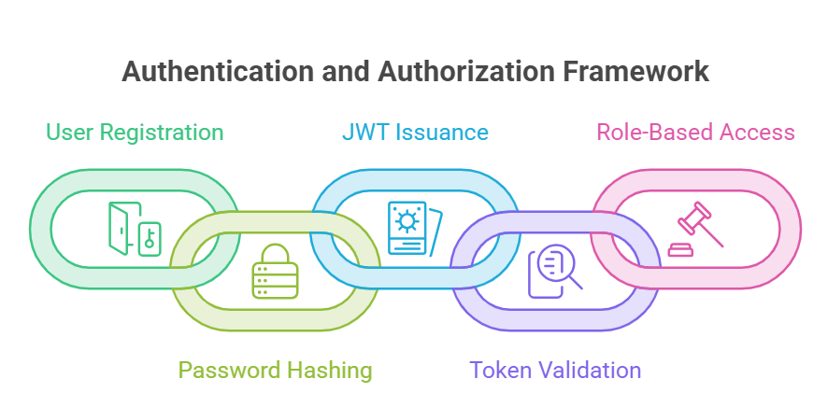

Component 2: Video Ingestion Pipeline
Processes uploaded video files through a multi-stage pipeline: audio extraction, transcription, translation, chunking, embedding, and vector storage. Runs asynchronously with progress tracking.
Implementation Steps:
- User uploads video file via multipart form POST to /ingest endpoint
- A unique job_id is generated and returned immediately for progress polling
- FFmpeg extracts audio track from the video container
- OpenAI Whisper transcribes the audio, detecting the original language automatically
- If the detected language is not English, Whisper translates the transcript to English
- Both original and English transcripts are saved to the PostgreSQL transcripts table
- English text is split into overlapping chunks (1000 chars, 150 overlap) using sentence-aware boundaries
- Chunks are saved to the transcript_chunks table with estimated timestamps
- Each chunk is embedded using the all-MiniLM-L6-v2 model (384 dimensions)
- Embeddings are stored in ChromaDB with metadata (transcript_id, chunk_index, timestamps)
- Job status is updated at each stage; frontend polls /ingest/status/{job_id} for progress
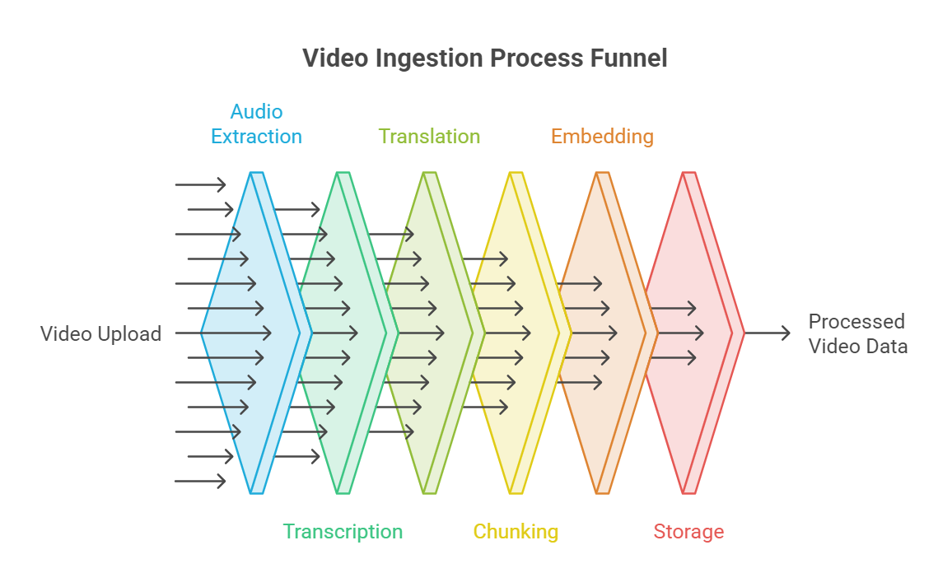

Component 3: Query and Answer Engine
Handles user questions by performing semantic search over stored embeddings and generating grounded answers using a large language model.
Implementation Steps:
- User submits a natural language question via POST to /query endpoint
- The question is embedded using the same all-MiniLM-L6-v2 model
- ChromaDB performs cosine similarity search to find the top-4 most relevant chunks
- Retrieved chunk texts are assembled into a context prompt
- The context and question are sent to Groq API (llama-3.3-70b-versatile, temperature=0.2)
- The LLM generates an answer grounded in the provided context
- The response includes the answer text and source citations with timestamps
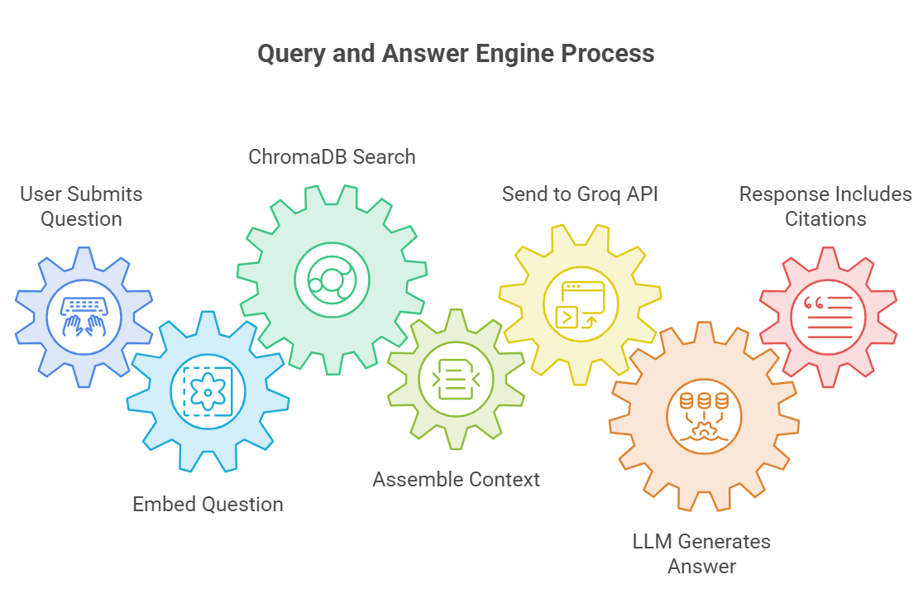

Component 4: Admin Dashboard
Provides administrative capabilities including user management, system alerts, platform analytics, and complaint resolution.
Key Features:
- Dashboard with summary statistics (total users, active users, total chats, total videos)
- User management: search, view details, block/unblock accounts
- System alerts: view, filter by type/status, resolve alerts
- Analytics: detailed metrics and usage patterns
Complaint management: view user tickets, provide admin responses, update status

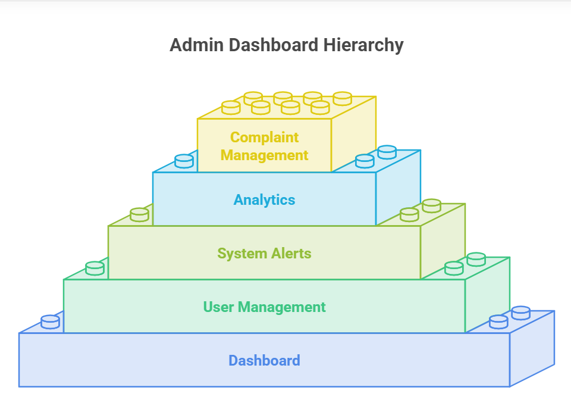
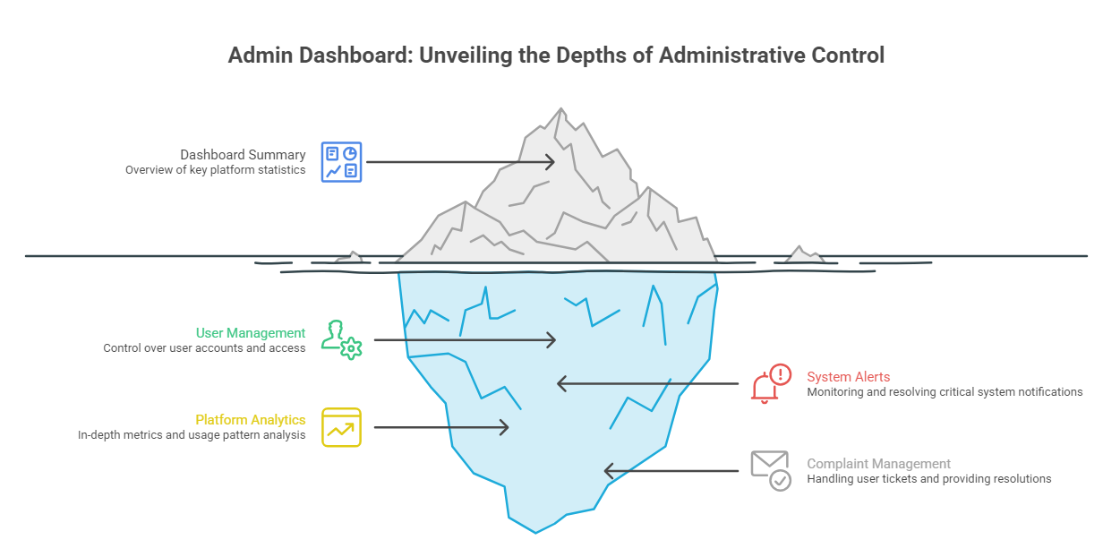

Component 5: User Chat Interface
The primary user-facing component providing a chat-based interface for video upload and Q&A interaction.
Key Features:
- Split-panel layout: left panel for Q&A responses, right panel for video upload and message input
- Real-time progress indicators during video processing (uploading, transcribing, translating, chunking, embedding)
- Chat history stored in browser localStorage for session persistence
- Video library with demo content for quick exploration
- User settings for profile management and theme preferences (dark/light mode)
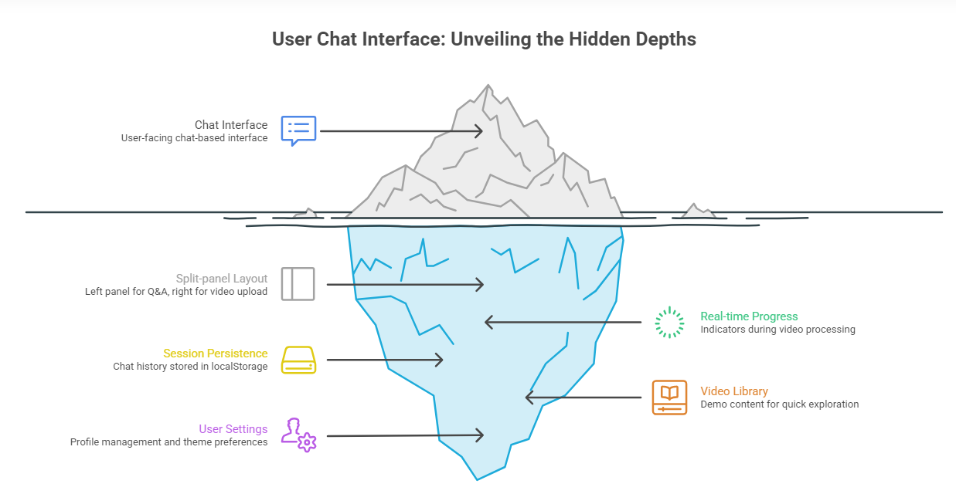

Interface Design
The application provides two distinct user interfaces based on role:
User Interface Pages:
- Login Page (/login) – Combined signup and signin with tab navigation
- User Dashboard (/) – Main chat interface with split-panel layout for Q&A interaction
- Video Library (/library) – Browse and access demo video lectures
- Recent Chats (/recent) – View previous chat sessions stored in browser memory
- Complaints (/complaints) – Submit and track support tickets
- Settings (/settings) – Profile management, preferences, and theme toggle
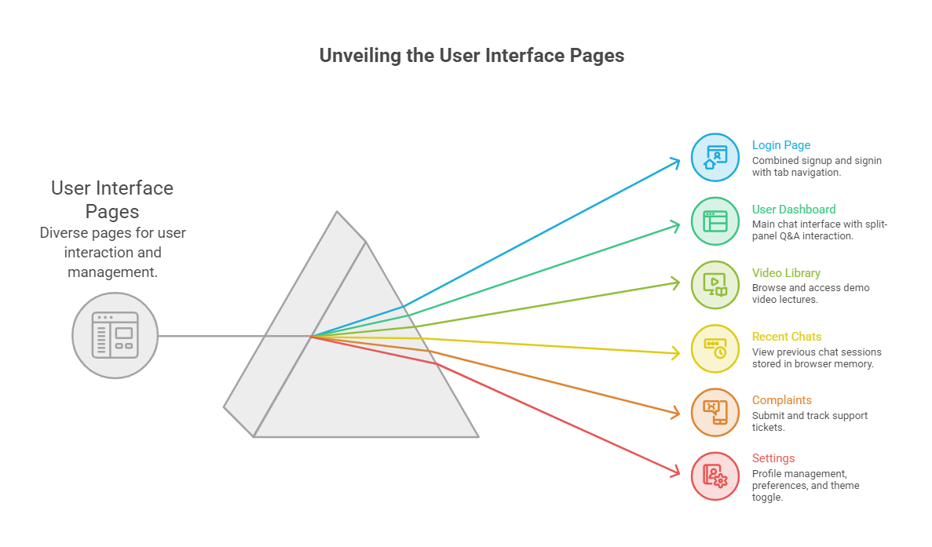
Admin Interface Pages:
- Admin Dashboard (/admin) – Overview with statistics cards, recent alerts, and user activity
- Alerts (/admin/alerts) – System and security alert management
- User Management (/admin/users) – Search, view, block/unblock users
- Analytics (/admin/analytics) – Detailed platform usage metrics
- Settings (/admin/settings) – Platform configuration
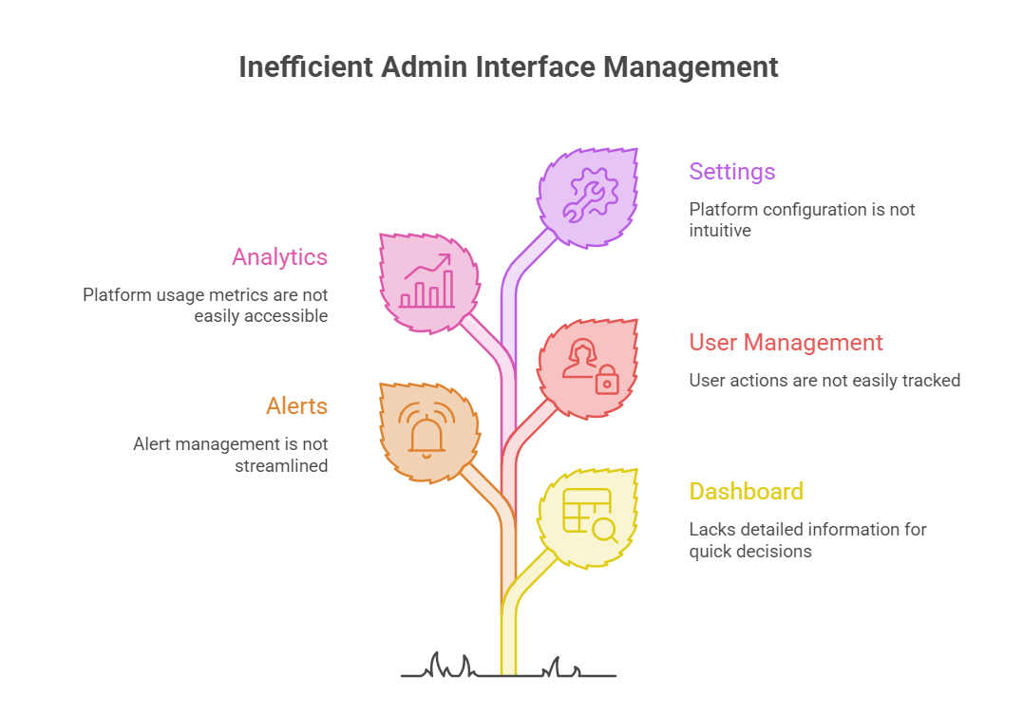

API Endpoints:
Backend API (port 8000, prefix /api):
Method | Endpoint | Auth | Description
POST | /auth/signup | None | Create new user account
POST | /auth/login | None | Authenticate and receive JWT token
GET | /auth/me | JWT | Get current user profile
GET | /users | Admin | List all users with filtering
PATCH | /users/{id}/status | Admin | Block or unblock a user
GET | /chats | JWT | List user chat sessions
POST | /chats | JWT | Create new chat session
GET | /videos | JWT | List videos with status filter
POST | /videos | JWT | Create video metadata entry
GET | /complaints | JWT | List complaints
POST | /complaints | JWT | Submit new complaint
GET | /alerts | Admin | List system alerts
GET | /analytics/summary | Admin | Get analytics summary

RAG Service API (port 8100):
Method | Endpoint | Auth | Description
POST | /ingest | None | Upload and process a video file
GET | /ingest/status/{job_id} | None | Poll ingestion progress
POST | /query | None | Ask a question about a transcript
GET | /health | None | Health check endpoint
GET | /viewer | None | Interactive ChromaDB browser
GET | /api/chroma/stats | None | Vector store statistics

Any Specific Design Considerations
- The system uses local embedding models (all-MiniLM-L6-v2) to avoid external API dependencies during indexing, keeping costs low and latency predictable.
- Whisper models can be configured by size (tiny, base, small, medium, large) to trade accuracy for resource usage – the tiny model is recommended for free-tier cloud VMs.
- The RAG service and backend share the same PostgreSQL database to avoid data synchronization overhead, while maintaining clear schema separation.
- Admin users are intentionally blocked from viewing user transcripts and chat content to preserve user privacy.
- The frontend stores chat history in browser localStorage for simplicity – server-side persistence through the chat_sessions and chat_messages tables is also supported.
- Video ingestion is processed asynchronously with background jobs to prevent HTTP request timeouts on large files.
- The Groq LLM is configured with temperature=0.2 to produce deterministic, factual answers grounded in the retrieved context rather than creative or speculative responses.
- CORS origins are configurable via environment variables to support both local development and production deployment scenarios.

Design Test
<Testing Team need to Update this section>
The following testing strategies are recommended for validating the design:
- Unit Tests: Test individual pipeline stages (chunking, embedding, retrieval) in isolation
- Integration Tests: Verify end-to-end ingestion flow from video upload to vector storage
- API Tests: Validate all REST endpoints with correct and incorrect inputs, authentication, and authorization
- UI Tests: Verify frontend components render correctly and handle all user flows
- Performance Tests: Measure transcription time, embedding generation speed, and query latency under load
- Security Tests: Validate JWT authentication, CORS enforcement, password hashing, and role-based access control
- Multilingual Tests: Verify transcription accuracy and translation quality across multiple languages

Cross Reference with System Requirement Specification

System Requirement Specification Features
API's Developed | Requirements | Adherence/Limitations
COMPONENT NAME
API name  (Eg /register) | Mapping with Functional requirement id (Eg FR1.1) | Meets the FR completely / partially /does not meet any additional functionality provided

The following table maps system requirements to implemented API endpoints and components:
SRS Feature | API/Component | Requirement | Adherence
User Registration | POST /auth/signup | FR1.1 | Fully meets requirement
User Authentication | POST /auth/login | FR1.2 | Fully meets requirement
Video Upload | POST /ingest | FR2.1 | Fully meets requirement
Auto Transcription | RAG Pipeline (Whisper) | FR2.2 | Fully meets – 99+ languages
Auto Translation | RAG Pipeline (Whisper) | FR2.3 | Fully meets – auto-detect and translate
Text Chunking | RAG Pipeline (chunking.py) | FR2.4 | Fully meets – sentence-aware
Vector Embedding | RAG Pipeline (embeddings.py) | FR2.5 | Fully meets – 384-dim local model
Question Answering | POST /query | FR3.1 | Fully meets – context-grounded
Source Citations | POST /query response | FR3.2 | Fully meets – timestamps included
Chat History | GET/POST /chats | FR3.3 | Fully meets requirement
User Management | GET/PATCH /users | FR4.1 | Fully meets – admin only
System Alerts | GET/POST /alerts | FR4.2 | Fully meets requirement
Analytics Dashboard | GET /analytics/summary | FR4.3 | Fully meets requirement
Complaint System | GET/POST /complaints | FR4.4 | Fully meets requirement
Dark/Light Theme | Frontend ThemeContext | FR5.1 | Fully meets requirement
Role-Based Access | JWT + role middleware | NFR1.1 | Fully meets requirement
Password Security | Bcrypt hashing | NFR1.2 | Fully meets requirement

Appendix A/B/C – Appendix Name

Details of appendix

Appendix A – Configuration Reference
Backend Environment Variables (.env):
Variable | Description
POSTGRES_SERVER | PostgreSQL host (default: localhost)
POSTGRES_PORT | PostgreSQL port (default: 5432)
POSTGRES_USER | Database username (default: postgres)
POSTGRES_PASSWORD | Database password
POSTGRES_DB | Database name (default: video_lecture_transcript)
SECRET_KEY | JWT signing secret key
ACCESS_TOKEN_EXPIRE_MINUTES | Token expiry in minutes (default: 10080 / 7 days)
BACKEND_CORS_ORIGINS | Allowed CORS origins
SEED_DEMO_DATA | Create demo accounts on startup (true/false)

RAG Service Environment Variables (.env):
Variable | Description
DATABASE_URL | PostgreSQL connection string
GROQ_API_KEY | Groq cloud API key for LLM access
WHISPER_MODEL | Whisper model size: tiny, base, small, medium, large
EMBEDDING_MODEL | Sentence-transformer model name
CHUNK_SIZE | Characters per chunk (default: 1000)
CHUNK_OVERLAP | Overlap between chunks (default: 150)
TOP_K | Number of chunks retrieved per query (default: 4)
CHROMA_DIR | ChromaDB persistent storage directory
CHROMA_COLLECTION | ChromaDB collection name
CORS_ORIGINS | Allowed CORS origins

Appendix B – Demo Accounts
Role | Email | Password | Notes
Admin | admin@example.com | password | Full admin access
User | user@example.com | password | Standard user access
Demo accounts are only created when SEED_DEMO_DATA=true in backend configuration.

